# Assignment Name: CSS Grid

## Due Date: See Canvas

## Goals:

You have been given the full html file with accompanying images and style sheets - one of which is partial. You will need to edit the stylesheet so that it matches the requirements below. A screen capture of the final result has been provided for both desktop and mobile view. As always, use best practices, e.g. using a default style sheet.

## Objectives:

1. Demonstrate ability to use CSS Grid for layout of page content
2. Demonstrate ability to use media queries to adjust how page content displayed on different devices.

## Resources:

Use the class Github site (<https://github.com/drewasselin/umsi-webdesign>) use the code from week_4_grid. You will need to edit the css stylesheet that creates a page that looks like the example below. ***This code does not need to pass the validators***.

## Requirements:

***Note, the css code has comments to guide you through these requirements. Do a search for “Your code here” to make incremental changes. In some cases the requirements may already be fulfilled in the partial CSS we supplied.***

1. All files and folders present, HTML file and CSS stylesheet in proper format, no styles in HTML. **DO NOT MAKE ANY CHANGES TO THE HTM**L
2. General page styles
   1. Any element that are focusable by default (eg. links, inputs) should have a 2px solid black border when focused. Use a generic selector.
3. Skip to content link (links with skip class) should have the following styles on all screen sizes
   1. Div is absolutely positioned, margin is set 40px above the margin of the page so it is hidden when not focused.
   2. A “skip to content” link should be hidden until in focus. Then it should be positioned at the top.
   3. Skip-to-content link should appear automatically without transition when a user has Reduced Motion option enabled. ***(This is done in a media query.)***
4. Nav children:
   1. List items should display horizontally with 20px of padding on the right side only
   2. Links should have no underline.
   3. When hovered over, links should have an underline
5. Mobile/default view: Grid container (container class) has 3 formatted columns of 100px, 500px, and 100px; and 7 rows - one of 30px, five rows of auto, and one last row of 100px.
   1. Container has a gap between grid rows of 15px
   2. The **text-block class** should be centered vertically and horizontally (think css grid) with 30px padding on all sides
   3. Media queries should be included:
      1. Styles of windows 800px or wider (henceforth referred to as desktop)
         1. Grid container (**container class**) has 5 formatted columns of 50px, auto, 500px, auto, and 50px; and 7 rows - one of 70px, 5 rows of 400px, and one last row of 100px.
      2. Styles for preferred motion reduction ( Zak – I am not sure about it)
         1. In-page links should “jump” to page content instead of scroll
6. The **nav class** should have the following styles
   1. The default (hence from **mobile)** view:
      1. Navigation is left aligned and **centered vertically ( Zak - I did padding top and botton. As per my search it seems padding top and bottom will make it vertical**. 20px padding on top and bottom only.
      2. Navigation begins in the first column and ends in the last column.
      3. Begins on row 1 and spans only 1 row.
   2. For desktop:
      1. Navigation is right aligned and centered vertically. 35px padding on top and bottom only
      2. Navigation begins in the first column and ends in the last column. Begins on row 1 and spans only 1 row.
7. Header section should have the following styles for both mobile and desktop
   1. Begins in the first column and spans the full width of the page, begins on row 2 and spans one row.
   2. Header uses header.jpg as a non-repeating background image with parallax effect (requires multiple properties)
8. About section (**about and about-image classes**) should have the following styles
   1. For mobile
      1. about begins in column 2 and spans one column; *begins on row 3 and spans 1 row*
      2. about-image contains only the about.jpg image with appropriate alt text; begins in column 1 and spans the full page, begins in row 3 and spans 1 row. Is no taller than 700px and any image content over that limit is not shown.
   2. For desktop
      1. about begins in column 3 and spans 2 columns; begins in row 3 and spans 1 row.
      2. about-image contains only the about.jpg image with appropriate alt text; begins in column 2 and spans 2 columns; begins in row 3 and spans 1 row. Is no taller than 700px and any image content over that limit is not shown
9. Method section (**method and method-image classes**) should have the following styles
   1. For mobile
      1. method begins in column 2 and spans one column; *begins on row 4 and spans 1 row*
      2. method-image contains only the method.jpg image with appropriate alt text; begins in column 1 and spans the full page, begins in row 4 and spans 1 row. Is no taller than 700px and any image content over that limit is not shown
   2. For desktop
      1. method begins in column 2 and spans 2 columns; begins in row 4 and spans 1 row.
      2. Method-image contains only the method.jpg image with appropriate alt text; begins in column 3 and spans 2 columns; begins in row 4 and spans 1 row. Is no taller than 700px and any image content over that limit is not shown
10. Clients section (**clients and clients-image classes**) should have the following styles
    1. For mobile
       1. clients begins in column 2 and spans one column; *begins on row 5 and spans 1 row*
       2. clients-image contains only the clients.jpg image with appropriate alt text; begins in column 1 and spans the full page, begins in row 5 and spans 1 row. Is no taller than 700px and any image content over that limit is not shown
    2. For desktop
       1. clients begins in column 3 and spans 2 columns; begins in row 5 and spans 1 row.
       2. clients-image contains only the clients.jpg image with appropriate alt text; begins in column 2 and spans 2 columns; begins in row 5 and spans 1 row. Is no taller than 700px and any image content over that limit is not shown
11. Contact section (**contact and contact-image class**) should have the following styles
    1. For mobile
       1. contact begins in column 2 and spans one column; *begins on row 6 and spans 1 row*
       2. contact-image contains only the contact.jpg image with appropriate alt text; begins in column 1 and spans the full page, begins in row 6 and spans 1 row. Is no taller than 700px and any image content over that limit is not shown
    2. For desktop
       1. contact begins in column 2 and spans 2 columns; begins in row 6 and spans 1 row.
       2. contact-image contains only the contact.jpg image with appropriate alt text; begins in column 3 and spans 2 columns; begins in row 6 and spans 1 row. Is no taller than 700px and any image content over that limit is not shown
12. Footer element should have the following styles
    1. Begins in column 1 and spans the full page; begins in row 7 and spans 1 row
13. Code is uploaded your GitHub account under the repo: homework4

## 

## Example

Mobile view - [fill view](https://drive.google.com/open?id=1BcZ28WIUwORULqdR_jOG_7PV48nli7ts)

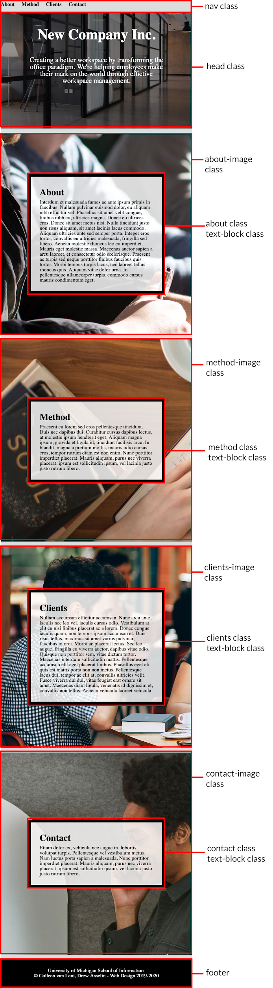

Desktop view - [full view](https://drive.google.com/open?id=1GLVDFjt0CHtPzhxfLjYnXLWlftJxdh7D)

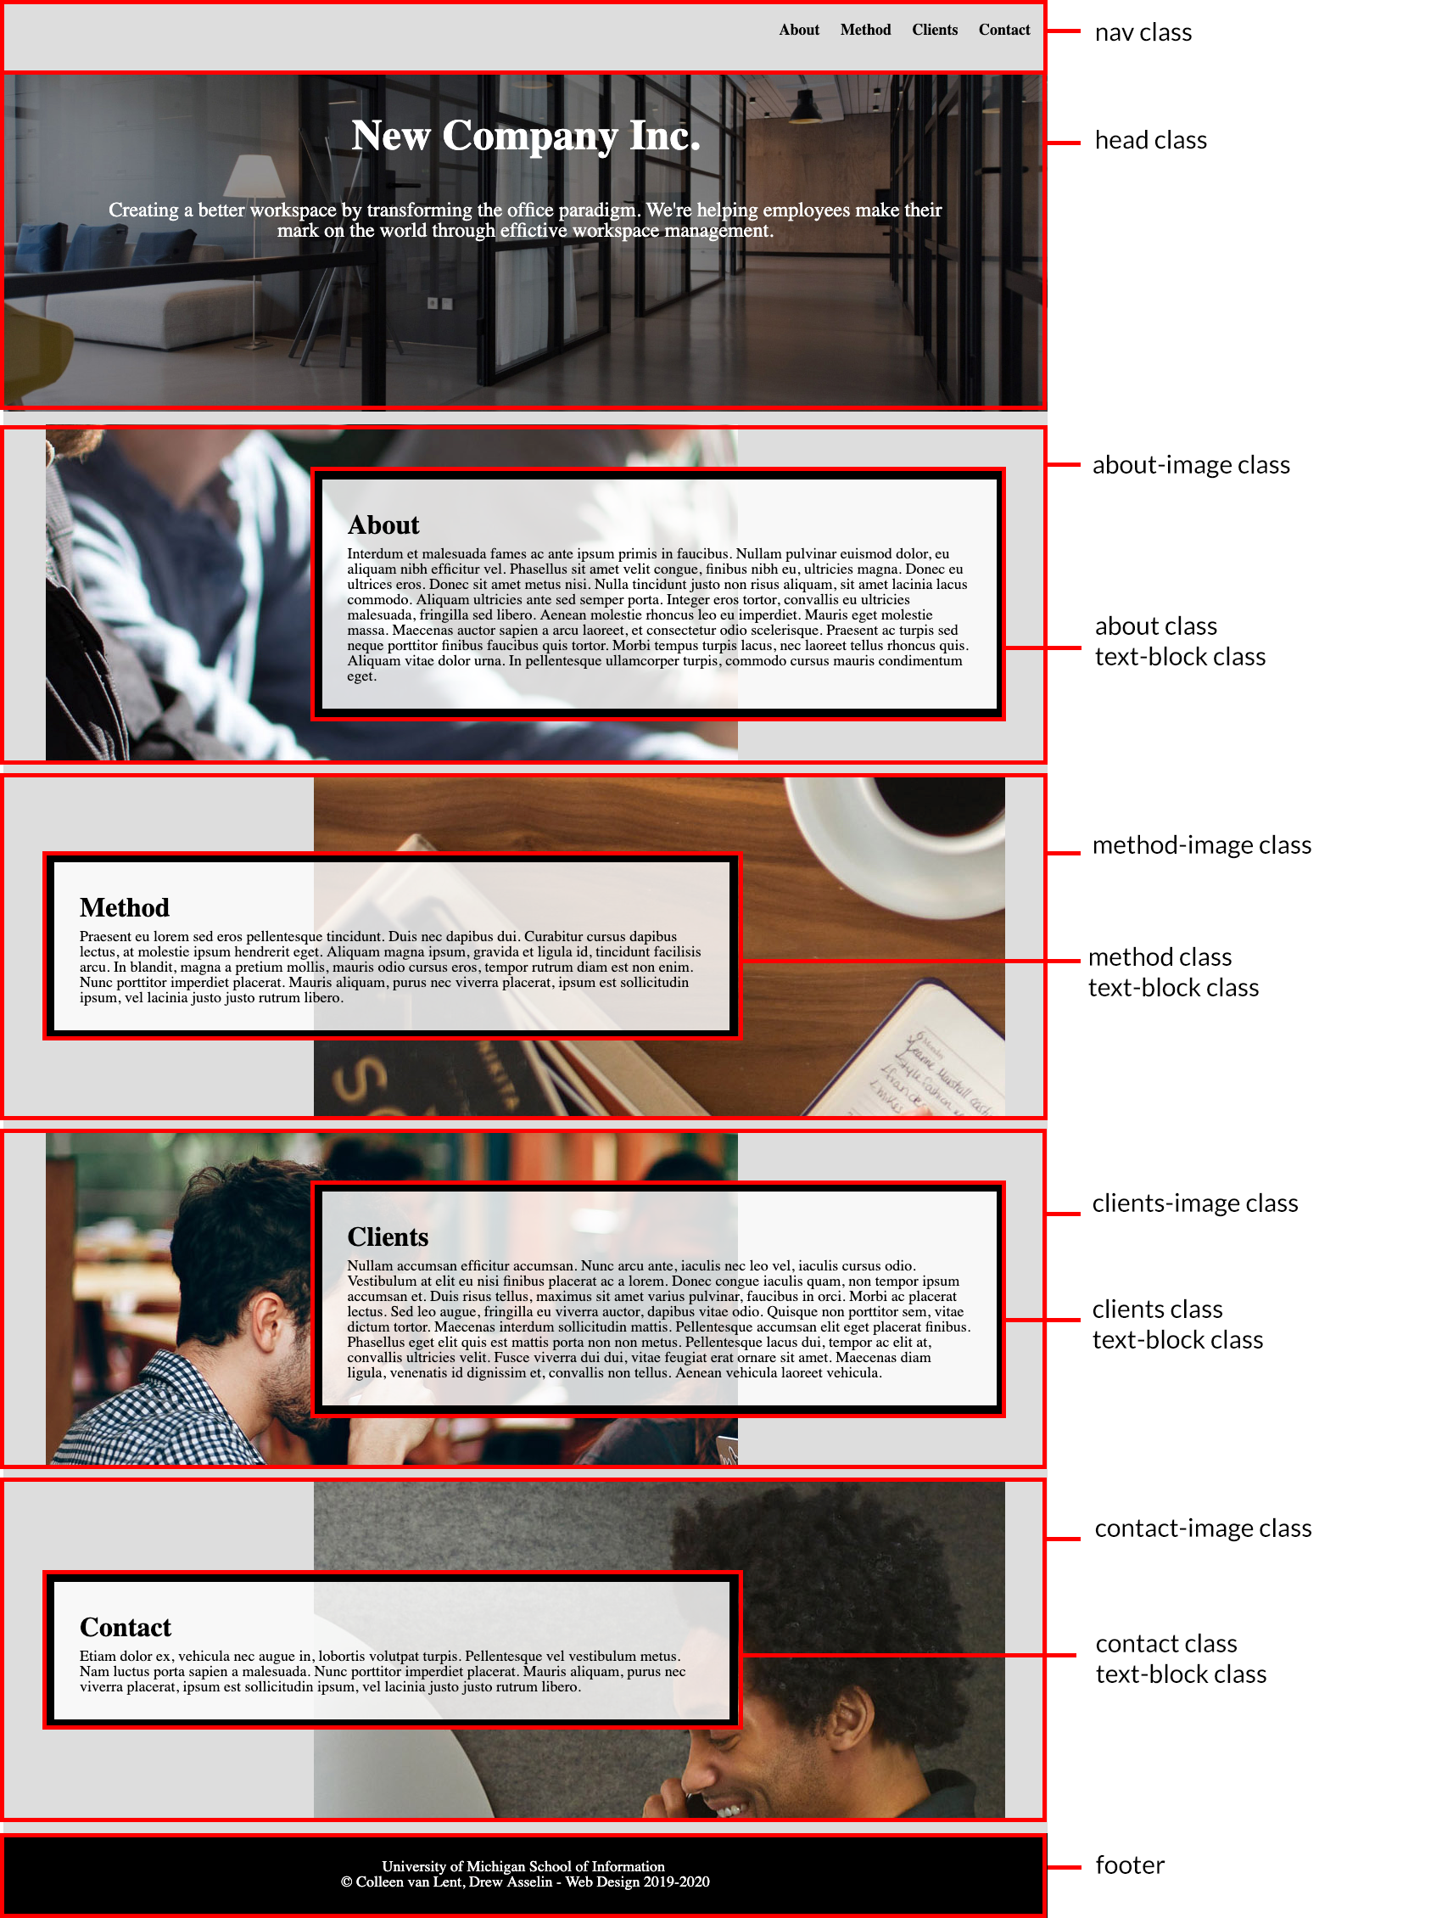

## 

## Tips!

1. Start with the css file and look for the places you should.
2. Get the mobile view complete before you start the desktop view.
3. If your rules cascade correctly, you should have fewer selectors in the desktop view

## Submission Requirements:

1. Submit link to git repo in canvas. We want to see the deployed page, not the code so the URL should be ***<your-user-name>.github.io/homework4***

### 